Elastics

What You Need:
- 3 friends at least
- A long piece of elastic, knotted to a loop – at least 2m long

How to Play:
Two children stand inside the loop so they are stretching it relatively taut around their ankles.
The others chant the rhyme “England, Ireland, Scotland, Wales, Inside, Outside, On the Scales“.
The third person starts with left foot inside the elastic loop and right foot just outside [this is England in rhyme]. Jump over to the other side so right foot is inside the loop and left foot is outside [this is Ireland]. Repeat same moves for Scotland, Wales. They then jump both feet “Inside”, both feet “Outside” and then land both feet on elastic for “On the Scales”.
If pass this level, the height of the elastic is raised to knees, then thighs, then waist.
Can also be played solo, with elastic around 2 chairs.

Hopscotch
Hopscotch is an old traditional game that still brings loads of fun and laughter in school yards everywhere. With these easy steps you can create your own hopscotch at home, inside or out!

What you need
- chalk or masking tape
- markers for each person playing - pebble, bottle cap, shell, button, etc.

How to play:
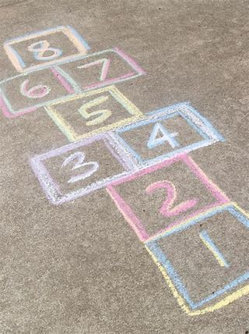
Use chalk to draw a hopscotch pattern on the ground or use masking tape on the floor.
Create a diagram like this picture

Each player has a marker such as a stone, bottle-cap, shell, button, etc.

The first player stands behind the starting line to toss his or her marker in square one.
Hop over square one to square two and then continue hopping to square eight,
turn around, and hop back again.

Pause in square two to pick up the marker, hop in square one, and out.
Then continue by tossing the stone in square two.

All hopping is done on one foot unless the hopscotch design is such that two squares
are side-by-side.

Then two feet can be placed down with one in each square.

A player must always hop over any square where a maker has been placed.

Getting out: A player is out if the marker fails to land in the proper square, the hopper steps on a line, the hopper loses balance when bending over to pick up the marker and puts a second hand or foot down, the hopper goes into a square where a marker is, or if a player puts two feet down in a single box.
The player puts the marker in the square where he or she will resume playing on the next urn, and the next player begins.

