Maths Activities Week Four (Resource 1)
Monday May 18th
Warm Up
Making patterns:
Start at 12 and count on in 3s. What is the pattern? Now start at 12 and count by 5s. How do the numbers change?

Inquiry Maths
Survey your family members about their favourite food, animal or hobby an idea of your choice
Use the Survey and graph paper attachment to record tallies.
Can you make a picture graph or bar graph to display your information?
Do you need more data? Can you ring or text other members of your extended family for more information.

Inquiry Maths – Survey and Graph
Survey your family members about their favourite food, animal or hobby an idea of your choice.
Use the Survey and graph paper attachment to record tallies.
Can you make a picture graph or a bar graph to display your information?
Do you need more data? Can you ring or text other members of your extended family for more information?

Tuesday May 19th

Warm Up
Bomb – Challenge one or two people to a game of Bomb.
You will need 21 counters or blocks of lego.
Take it in turns to take 1, 2 or 3 objects at a time. Whoever has to take the last counter ‘bombs’ out and loses the game.
Keep a tally of who wins.

Main Activity
Money
Make a grocery list for your family.
Find out how much five items cost (to the nearest dollar). Add them together to find the total amount spent.
You might like to use a receipt from the last time your parents went shopping or a catalogue to get an idea of how much items cost.
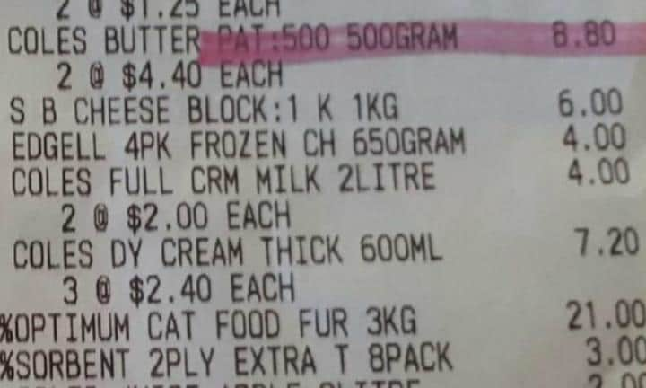

Example
Milk | Cereal | Sausages | Bread | Biscuits | Total
$2 | $5 | $6 | $3 | $4 | $20

Total

Wednesday May 20th

Warm Up
Practise your friends of ten (pairs of numbers that total 10) or if you know these automatically practise friends of 20 (pairs of numbers that total 20).
Challenge yourself with Friends of 100 (pairs of numbers that total 100) by asking someone to give you a number between one and 100. Eg, 55. Tell them it’s partner = 45. Record your answers.
Are you ready to Extend to friends (pairs) of 1000?!

Main Activity

Mapping
Map your house.
Draw a bird’s eye floorplan of your house. Label each room of your house with the main items such as your couch and kitchen bench.
Example
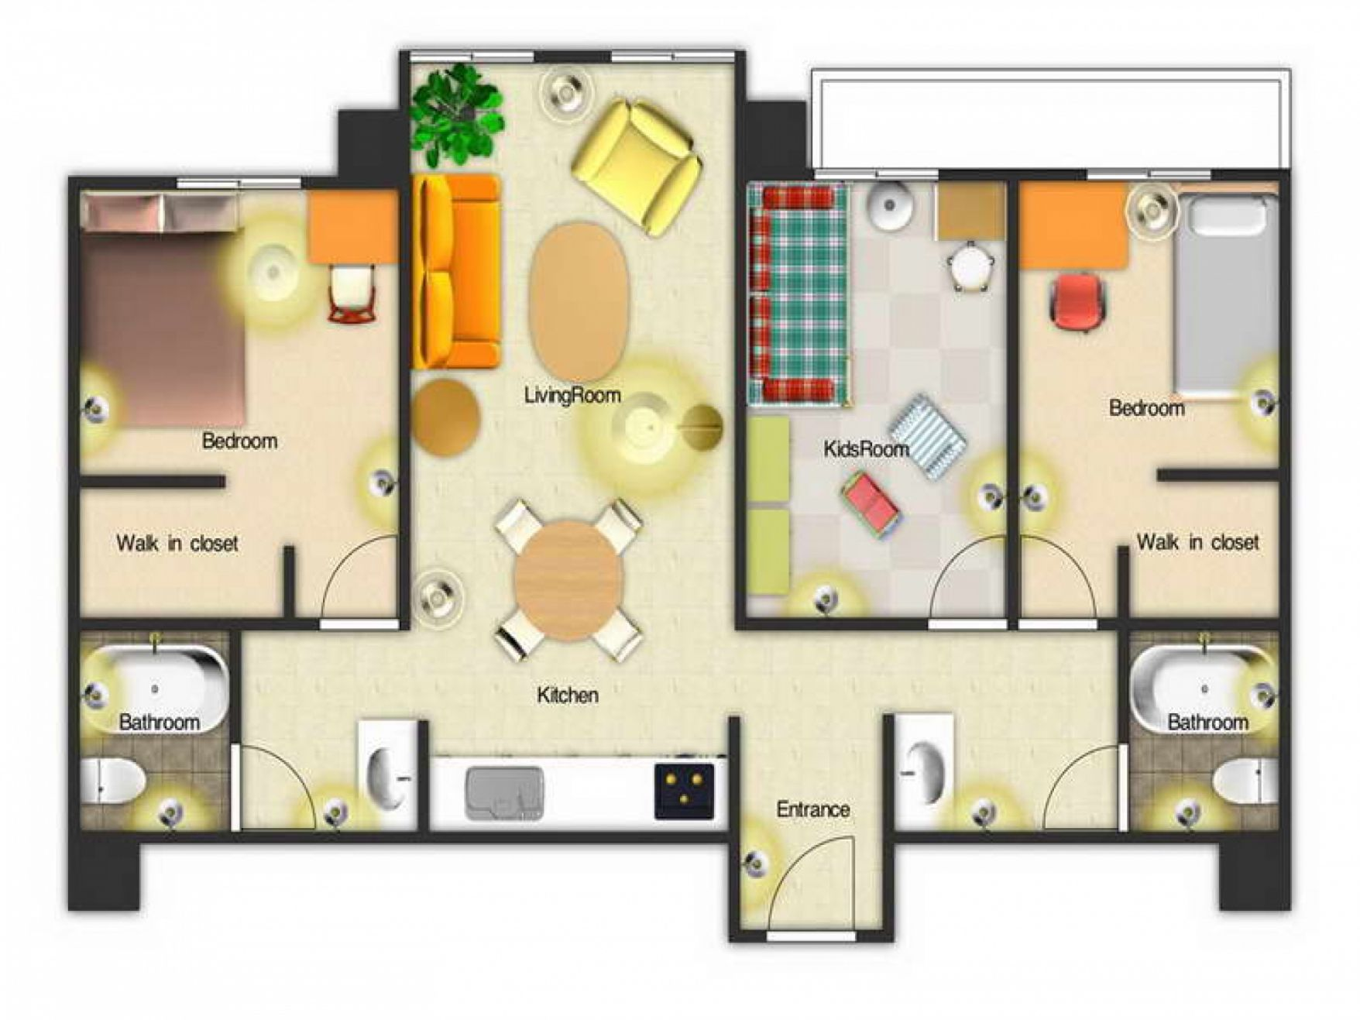

Thursday May 21st
Number Warm Up –Skip counting
Write down a two-digit number or find it on your 1-100 chart. (Challenge – choose a 3 or 4 digit number)
Count backwards from your number in 2s, then 10s. until you reach a single digit number.

Boom
Creating the game (Boom):
On strips of cardboard or paddle pop sticks, write down equations to test people in your family using any operations you know (+ - × ÷)
An example is 20 – 5. (You must know the answer). Place them in a jar or box and label it the Boom Jar or Boom Box.
Include 3 strips with BOOM written instead of a sum.
Playing Boom - Challenge a member(s) of your family to play Boom, by taking it in turns to pick out a strip/stick. If someone answers the sum correctly then they keep the sum in their pile.
If a player picks out BOOM they have to return all their sticks to the jar.
Invite family members to add sums to the Boom Jar for next time you play.

Friday May 22nd
Maths Warm up – Reflection:
Draw a circle to represent a traffic light in your maths book and colour it green, orange or red, depending on how easy or hard you found the maths jobs this week.
Green: I found the maths jobs easy, I can teach these activities to a friend and I’ve been challenging myself.
Orange = I needed a bit of help with these activities but I’m getting the hang of them.
Red – A lot of activities were confusing. I needed help to finish most jobs.
Fill in the table
The maths job I enjoyed this week | Most challenging Maths job | What I learnt in maths this week

See Main Activity - Friday Fun on next page

Friday Fun
Choose from the following activities
- Abcya https://www.abcya.com/grades/1
- Cards/Uno 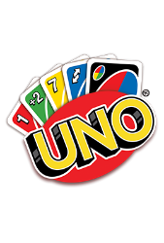
- Puzzle 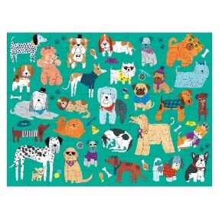

- Boardgame, eg, Monopoly / connect four 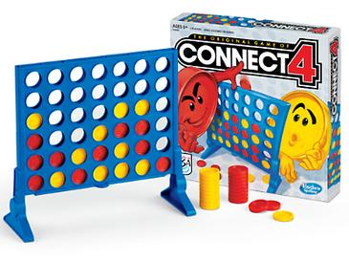

- Lego construction

- Personal maths development (practise a page of maths of your choice)

